**Multi_Job (Parallel Execution of tasks)**

**Prerequisite:**

1. Jenkins should be up and running
2. Plugins need to be installed
3. Ant plugin
4. Junit plugin
5. Multi-job plugin
6. Build-pipeline plugin

(also import dependency plugins that need to be installed)

1. Jenkins->manage Jenkins->global tool configuration

Mention Ant installation

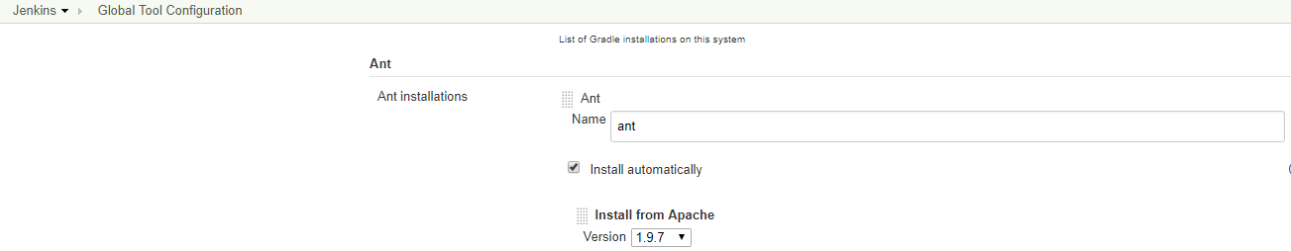

**Job-Configuration**

1. **Compile and Instrumentation of the code AntProject_Compile_Instrument**
2. **Local Configuration**

Create New item->freestyle project

1. **Under Advanced Project Options**

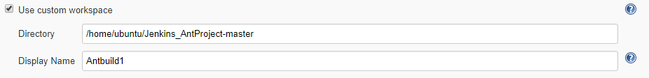

Directory : Mention the custom workspace directory

DisplayName : Display name of the project

1. **Build**

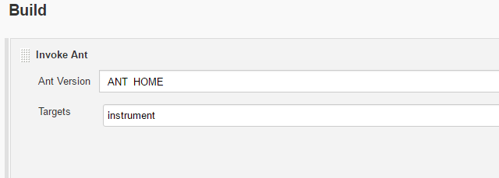

Select->invoke ant

Ant version : select the ant home in the dropdown

Targets : mention the target which has to be takes place(Target name as same as <target> specified in the build.xml ,**Note : refer compiling and instrumenting documentation)**

->Save->BuildNow

In Console

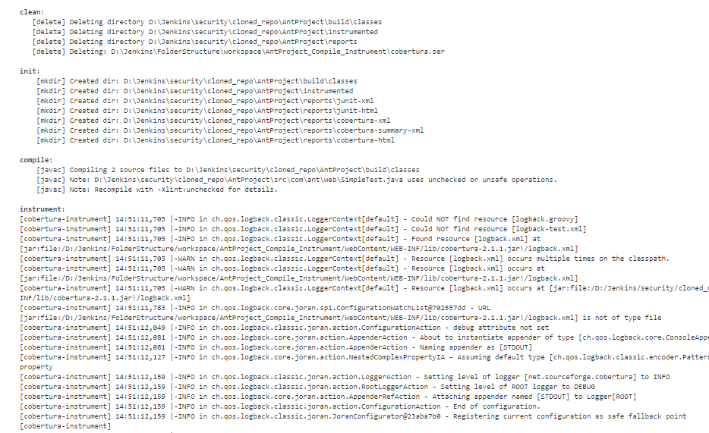

Build Successful!!!

1. In **Post build action**->build other project

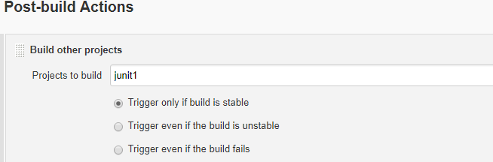

Give name of the other project which has to be run in sequential step

1. **JUnit**
2. **Local Configuration**

Create New item->freestyle project

1. **Under Advanced Project Options**

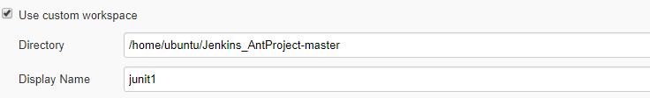

Directory : Mention the custom workspace directory

DisplayName :Display name of the project

1. **Build**

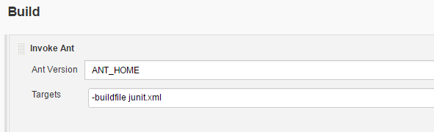

Select->invoke ant

Ant version : select the ant home in the dropdown

Targets : mention the target which has to be takes place(Target name as same as <target> specified in the junit.xml, **Note : refer junit document**)

1. **Post-build Actions**

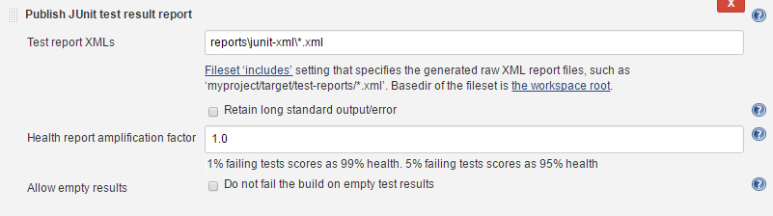

In **Post-build action** -> Publish Junit test results reports

a.Test repost XMLs –mention the space where the xml report found in the project structure

|  |  |
| --- | --- |
|  | [Fileset ‘includes’](http://ant.apache.org/manual/Types/fileset.html) setting that specifies the generated raw XML report files, such as ‘myproject/target/test-reports/*.xml’. Basedir of the fileset is [the workspace root](http://localhost:8888/job/Junit/ws/). |

->Save->BuildNow

In Console

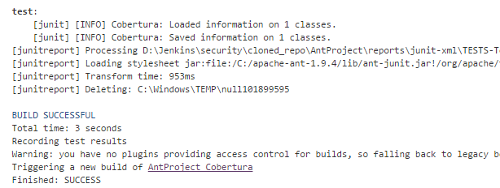

Build Successful!!!

**(Note:- Same steps 1 & 2 should be followed for any other project which has to be done in parallel )**

1. **Multi-Job Configuration**

**a.Local Configuration**

**I.Build**

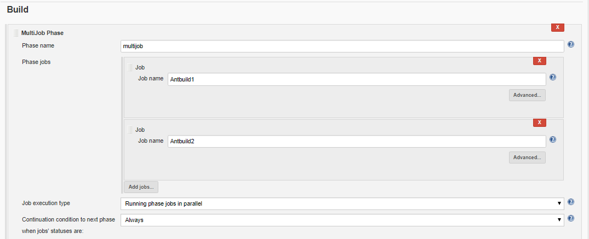

1. **Phase name:**

Define the name of the MultiJob Phase

1. **Phase Jobs**
2. Define the name of the jobs which has to be done in parallel

->Save->BuildNow

In Console

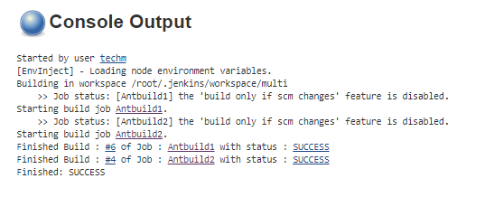

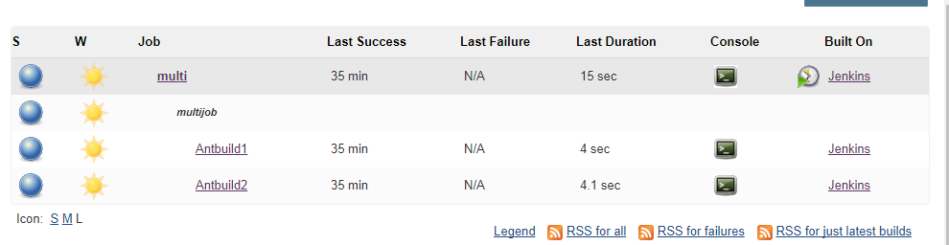

Build Successful!!!

**Jenkins Pipeline**

To create a build pipeline add **Pipeline Plugin**

From this link <https://wiki.jenkins-ci.org/display/JENKINS/Build+Pipeline+Plugin>

In Jenkins UI,Click on ”+” sign in order to add pipelin

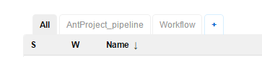

New pipeline

View name: name of the pipeline

click on build pipeline view

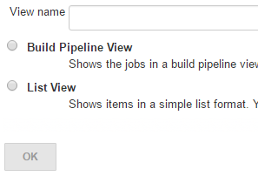

Click on OK

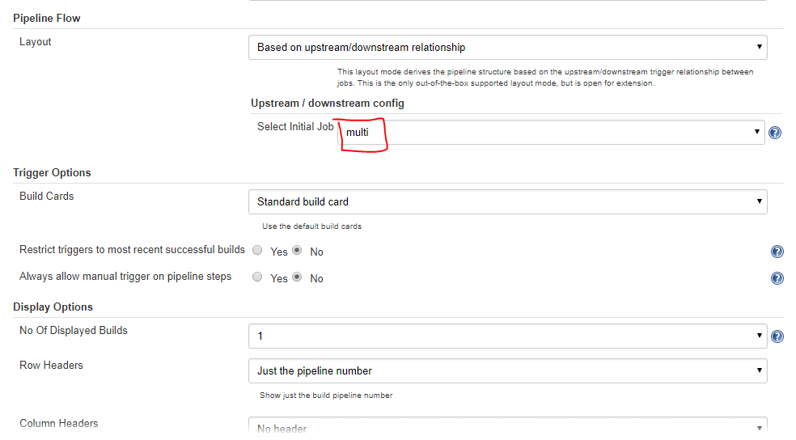

Select initial job: select the first project which has to be execute first in the pipeline

And click OK

Pipeline will appear ->click ->run

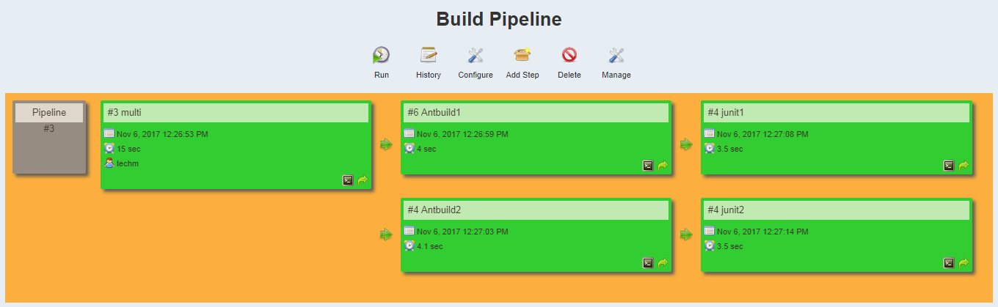

Jobs executed in parallel!!!